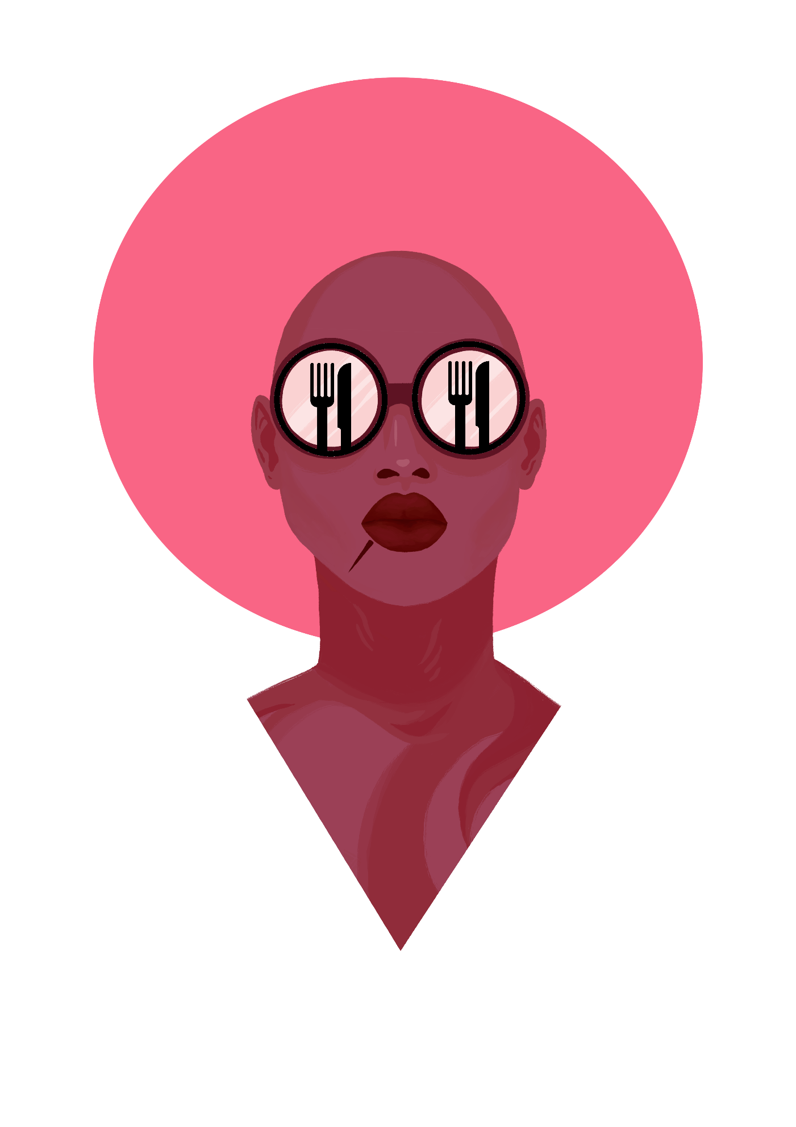
LOGLINE:
‘A show based around food and conversation”
SYNOPSIS:
“Stevie Boi Eats” is a 3-10 minute interval cooking show. The show focuses on Boi cooking at home, abroad or dining at his favorite or unfamiliar/unique restaurants around the world. The show is not intended to be in a cookie cutter format. “SBE” explores a ruse to drink, travel, cook, explore, get into trouble, and just talk to normal people about food. Boi & his guest bond over a quality experiences and these dinners take place in a luxurious location like on private yachts, landmark restaurants, on jets & other creative locations. The show occasionally features celebrity guest and entertainers that indulge and share their views on politics/culture/fashion. Our goal is to not bore our audience with political issues, but to inspire them to try new cuisines and travel more regardless what issues are at arise in the world. Boi uses his own personal journey to find commonalities with guests, and build constructive dialogue. The theme of the show is to remain non-intrusive with the guests, friends and restaurant owners, but concentrate on the food and gradually pull out the guests conversations/stories that aren’t being discussed typically in the media. Making the show interactive, with two different agendas, the cooking & social components make it more approachable from the viewer’s perspective. We expect to provide a luxury experience for our guests, opening up sponsorship and product placement opportunities.
Stevie Boi’s cooking lessons will also be added into select episodes; featuring either intimate or family style dinners. The lessons will cover the entire process of meal preparation, tasting, temperatures, recipes, and finishes. Boi will have a chance to share personal thoughts, favorite dishes or “one-on-one” moments with his audience. The show is intended to capture the attention of the younger generation by allowing the viewer to gain a perspective from an influential tastemakers of the entertainment today. Throughout his segments we will be able to seed embedded marketing tactics for our in-house merchandise and product line.
DEMOGRAPHIC:
Men and women, 18 - 35 who enjoying trailblazing, fine dining, cooking, traveling and thrill-seeking. Society has produced an entire offspring that carries the ability to explain themselves rationally, who are of color, various backgrounds and orientations and can communicate effectively to both the lower & middle, as well as upper class.

PRODUCTION & CAST:
The “SBE” Film crew is very small. We want to keep the crew small to create a more efficient way of travel and budgeting. Boi is the creator and lead for the show. He will mostly be accompanied with repeating guest such as Naomi Coleman & Michael Antonio. Additional guest will be added as the show flourishes.
FILMING:
The filming and editing process of the show should be fun and comedic. “Diners, Drive-Ins and Dives” is a great example of how we would want the show edited. Boi has a snarky personality that includes puns & facetious remarks. We would like the editing process to include unique ways to keep our viewers involved and watching. This includes sound effects, fun fact memos, Cartoons etc.
EPISODES:
“SBE” Episodes can range from 3-10 minutes. We plan to have 8 episodes in total until April of 2018. This does not no include additional promo that will be posted on the @StevieBoiEats Instagram page as well as on Stevie Boi’s other social media sites.
RELEASE DATE:
Our goal is to release the first episode February 4th of 2018. 1 Episode per week. Every Sunday a new episode will premiere with one week prior advertising via social media.

